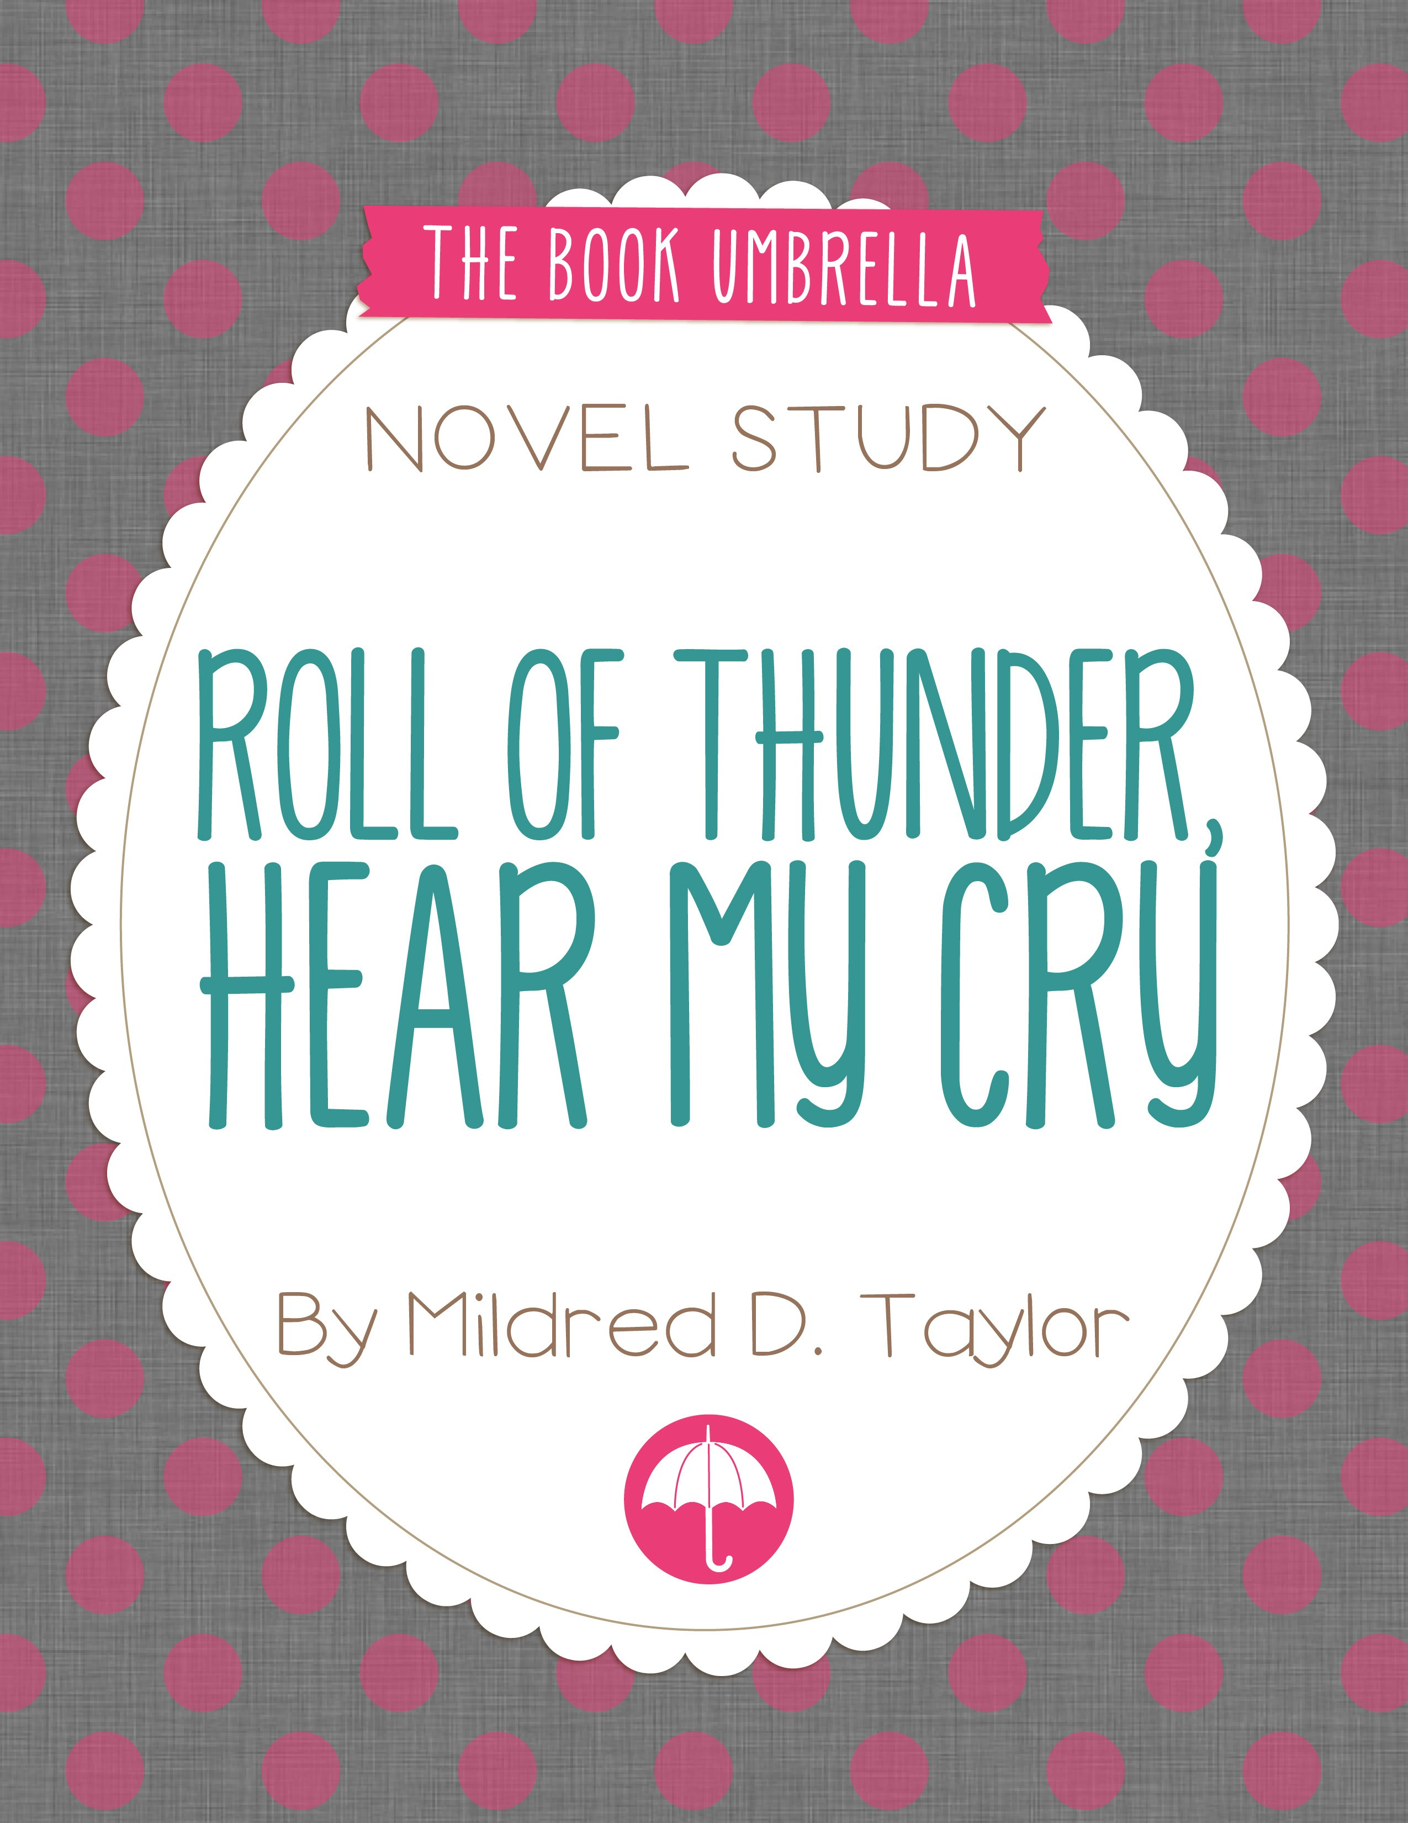

*Roll of Thunder, Hear My Cry*

Table of Contents

Novel Study Title Page for Students 3

Dictionary Detective! Chapters 1 – 2 4

Vocabulary Study Chapters 1 – 2 5

Understanding the Story Chapters 1 – 2 6

Chapter Summary Chapters 1 – 2 7

Dictionary Detective! Chapters 3 – 4 8

Vocabulary Study Chapters 3 – 4 9

Understanding the Story Chapters 3 – 4 10

Chapter Summary Chapters 3 – 4 11

Dictionary Detective! Chapters 5 – 6 12

Vocabulary Study Chapters 5 – 6 13

Understanding the Story Chapters 5 – 6 14

Chapter Summary Chapters 5 – 6 15

Dictionary Detective! Chapters 7 - 8 16

Vocabulary Study Chapters 7 - 8 17

Understanding the Story Chapters 7 - 8 18

Chapter Summary Chapters 7 - 8 19

Dictionary Detective! Chapters 9 – 10 20

Vocabulary Study Chapters 9 – 10 21

Understanding the Story Chapters 9 – 10 22

Chapter Summary Chapters 9 – 10 23

Dictionary Detective! Chapters 11 – 12 24

Vocabulary Study Chapters 11 – 12 25

Understanding the Story Chapters 11 – 12 26

Chapter Summary Chapters 11 – 12 27

Time for a Test! 28

Answer Key 30

Comprehension Worksheets 44

Reading Log 64

Common Core State Standards 65

© The Book Umbrella



Roll of Thunder,

Hear My Cry

by Mildred D. Taylor

A Novel Study by:

© The Book Umbrella

## Dictionary Detective!

###### Chapters 1 - 2

*Using a dictionary, find the definitions for the words below.*

**raucous**

Definition:

**sharecropping**

Definition:

**emaciated**

Definition:

**reverberated**

Definition:

**temerity**

Definition:

**imperiously**

Definition:

Match Up

Vocabulary Study

###### Chapters 1 - 2

*Match the words in the left column to their definitions in the right column.*

emaciated • temerity • imperiously • sharecropping •

raucous • reverberated •

* farming system in which farmers give a part of each crop as rent
* confidence in the face of danger
* loud and unpleasant to listen to
* echoed; rang throughout an area
* acting like the boss or commander
* thin as a result of not having enough to eat

reverberated imperiously sharecropping temerity raucous emaciated

Understanding the Story

Chapters 1 - 2

Multiple Choice

1. Why does Little Man refuse to accept his used textbook from Miss Crocker and instead stomps on it?
2. It belongs to someone else.
3. It has an offensive word in it.
4. It is worn and dirty.
5. It is too easy for him to read.

###### Short Answer

1. How does Mrs. Logan react to what Little Man has done?
2. She does not condemn it and instead fixes the book so it can be used.
3. She agrees with Miss Crocker and promises to punish Little Man.
4. She cries about the incident and buys Little Man a brand new book.
5. She feels scared about it and asks Miss Crocker not to tell anyone.
6. Describe Mr. Morrison and infer why he has come to live with the Logans.

###### Long Answer

1. How does the burning of the Berry men affect Cassie and her community?

## Chapter Summary

###### Chapters 1 - 2

1. If you were to give a title to this section of the book, what would it be?

2. What happens in these chapters?

3. What is your favorite part of this section of the book?

1. What new words did you learn in these chapters?

5. Draw a picture of something you think represents these chapters.

Name: Date:

Dictionary Detective!

Chapters 3 - 4

*Using a dictionary, find the definitions for the words below.*

**resiliency**

Definition:

**embittered**

Definition:

**adamantly**

Definition:

**precariously**

Definition:

**admonished**

Definition:

**feigned**

Definition:

Which Word?

Vocabulary Study

Chapters 3 - 4

*On the provided lines, write the matching vocabulary word for each definition.*

adamantly feigned admonished resiliency precariously embittered

* 1. With risk or danger.
  2. Ability to recover from or adjust to something bad.
  3. Fake or artificial.
  4. Made more angry.
  5. Spoken with disapproval or criticism.
  6. Firmly, strongly, or stubbornly.

Understanding the Story

Chapters 3 - 4

Multiple Choice

1. What regular event makes the Logan kids’ walk to school particularly awful?
2. The neighbors laugh at them as they pass by.
3. White children tease and push them.
4. The walk through the dark forest is scary.
5. The “white” bus always splashes them or sends them scrambling up the bank.

###### Short Answer

1. How does Stacey fix the problem he and his family encounter on the way to school?
2. He “borrows” the family wagon and gives everyone a ride home.
3. He asks his mother to stay later at school and walk home with her at night.
4. He convinces his brothers and sister to take another route home from school.
5. He gets his brothers and sister to dig

a huge trench in the road for the bus to hit.

1. At what point in the story do you start to feel afraid for what the children do to the road? Include details from the story in your answer.

###### Long Answer

1. What prompts Stacey to go to the Wallace’s store? Summarize what happens there as well as the outcome. Explain how Stacey’s mother reacts to the situation.

## Chapter Summary

###### Chapters 3 - 4

1. If you were to give a title to this section of the book, what would it be?

2. What happens in these chapters?

3. What is your favorite part of this section of the book?

1. What new words did you learn in these chapters?

5. Draw a picture of something you think represents these chapters.

Dictionary Detective!

Chapters 5 - 6

*Using a dictionary, find the definitions for the words below.*

**malevolently**

Definition:

**sullenly**

Definition:

**wryly**

Definition:

**ominously**

Definition:

**reverently**

Definition:

**languidly**

Definition:

Match Up

Vocabulary Study

###### Chapters 5 - 6

*A synonym is a word that means the same as another word. For example, happy and joyful are synonyms.*

*Match the vocabulary words with their synonyms!*

reverently •

wryly • sullenly • languidly • malevolently • ominously •

* + mockingly
  + maliciously
  + respectfully
  + threateningly
  + angrily
  + sluggishly

Understanding the Story

Chapters 5 - 6

Multiple Choice

1. Overall, how does Cassie’s trip to Strawberry go?
2. It is pleasant and fun.
3. It is exciting and interesting.
4. It is a dangerous disaster.
5. It is boring and uneventful.

###### Short Answer

1. How was Cassie “hurt” by the events in Strawberry?
2. Her arm was twisted, she fell, and she banged her head.
3. Her pride, sense of justice, and spirit were hurt.
4. Her friendship with Stacey and T.J. was hurt.
5. Her friendship with Jeremy and Lillian-Jean was hurt.
6. Why does Cassie’s mother have a long talk with her in Chapter 6?

###### Long Answer

1. Explain what Mrs. Logan means when she says to Cassie, “White people may demand our respect, but what we give them is not respect but fear.”

## Chapter Summary

###### Chapters 5 - 6

1. If you were to give a title to this section of the book, what would it be?

2. What happens in these chapters?

3. What is your favorite part of this section of the book?

4. What new words did you learn in these chapters?

5. Draw a picture of something you think represents these chapters.

Dictionary Detective!

Chapters 7 - 8

*Using a dictionary, find the definitions for the words below.*

**admonished**

Definition:

**interminable**

Definition:

**placid**

Definition:

**insolently**

Definition:

**jovial**

Definition:

**prophesied**

Definition:

Match Up

Vocabulary Study

###### Chapters 7 - 8

*Match the words in the left column to their definitions in the right column.*

placid • jovial • prophesied • interminable • admonished • insolently •

* calm and steady
* spoken to in a disapproving way
* predicted the future
* showing a lack of respect
* cheerful and fun-loving
* going on for a long time; never ending

insolently prophesied interminable admonished placid jovial

## Understanding the Story

###### Chapters 7 - 8

Multiple Choice

1. In Chapter 7, Stacey loses one gift and gains another. What are the gifts?
2. An orange and a yo-yo.
3. A bag of candy and a new book.
4. A book and a pair of shoes.
5. A coat and a wooden flute.

###### Short Answer

1. Mr. Jamison visits the family and pledges to:
2. Provide jobs for sharecroppers farming on Mr. Granger’s land.
3. Financially help those shopping in Vicksburg.
4. Provide new materials for Mama’s school.
5. Convict the Wallaces of Mr. Berry’s burning and put them in jail.
6. What does Mr. Granger hope to accomplish when he visits the Logan family in Chapter 7?

###### Long Answer

1. Explain the connection between T.J. failing Mrs. Logan’s exams and Mrs. Logan losing her job. Why is T.J.’s apology not satisfactory to the Logan kids?

## Chapter Summary

###### Chapters 7 - 8

1. If you were to give a title to this section of the book, what would it be?

2. What happens in these chapters?

3. What is your favorite part of this section of the book?

4. What new words did you learn in these chapters?

5. Draw a picture of something you think represents these chapters.

Name: Date:

Dictionary Detective!

Chapters 9 - 10

*Using a dictionary, find the definitions for the words below.*

**persnickety**

Definition:

**resigned**

Definition:

**immobilized**

Definition:

**despondently**

Definition:

**condemning**

Definition:

**reproachfully**

Definition:

Which Word?

Vocabulary Study

Chapters 9 - 10

*On the provided lines, write the matching vocabulary word for each definition.*

condemning persnickety despondently reproachfully resigned immobilized

1. Having the traits of a snob.
2. In a way that shows gloom or discouragement.
3. Held still or in a fixed position.
4. With disapproval.
5. Accusing or denouncing.
6. Accepted that something will happen.

Understanding the Story

Chapters 9 - 10

Multiple Choice

1. According to Jeremy, how do T.J.’s “new” friends treat him?
2. They help him by teaching him to read and write better.
3. They trick him and like to get him in trouble with other whites.
4. They would do anything for him and think he’s a great guy.
5. They’re nice to his face but make fun of him behind his back.

###### Short Answer

1. How do the Logans end up paying for their land when the bank calls in their mortgage?
2. Papa and Mr. Morrison get extra jobs on the railroad.
3. Uncle Hammer sells some things to help pay.
4. Mama starts working at the Wallace’s store.
5. Big Mama and Mama take in washing and mending.
6. What happens to Papa on the way home from Vicksburg?

###### Long Answer

1. Infer what T.J. hopes to accomplish when he introduces his “new” friends at the church revival in Chapter 10. Explain your answer.

## Chapter Summary

###### Chapters 9 - 10

1. If you were to give a title to this section of the book, what would it be?

2. What happens in these chapters?

3. What is your favorite part of this section of the book?

1. What new words did you learn in these chapters?

5. Draw a picture of something you think represents these chapters.

Dictionary Detective!

Chapters 11 - 12

*Using a dictionary, find the definitions for the words below.*

**frenzied**

Definition:

**vulnerability**

Definition:

**crescendo**

Definition:

**traipsing**

Definition:

**menacingly**

Definition:

**acrid**

Definition:

Match Up

Vocabulary Study

###### Chapters 11 - 12

*Match the vocabulary words with their synonyms!*

crescendo • traipsing •

acrid • frenzied • menacingly • vulnerability •

* + harsh (taste or smell)
  + roaming
  + frantic
  + escalation
  + weakness
  + threateningly

Understanding the Story

Chapters 11 - 12

Multiple Choice

1. What do Melvin and R.W. do to T.J.?
2. They buy him the gun with the pearl handle.
3. They take back the suit they gave him and beat him.
4. They frame him for burglary and beat him up.
5. They leave him on the side of the road and run away.

###### Short Answer

1. How does Mr. Logan keep the white men from hurting T.J. and his family?
2. He joins Mr. Jamison and calls the sheriff.
3. He sets a portion of his cotton field on fire.
4. He brings his gun and begins to fight all the men.
5. He calls on Uncle Hammer and Mr. Morrison.
6. Why do you think the author chose to begin Chapter 11 with a poem?

###### Long Answer

1. What makes Mr. Logan take the course of action he chooses in Chapter 12 to stop the white men from taking T.J. away?

## Chapter Summary

###### Chapters 11 - 12

1. If you were to give a title to this section of the book, what would it be?

2. What happens in these chapters?

3. What is your favorite part of this section of the book?

4. What new words did you learn in these chapters?

5. Draw a picture of something you think represents these chapters.

###### Part A – Multiple Choice

1. The issuance lists in the front of Cassie and Little Man’s books show that:
2. Black students get the best of what the county can afford.
3. Black students are thought of as second-class.
4. Black students get up-to- date information in their books.
5. Black students work hard and are well rewarded.
6. During the time period and setting of this book, black people:
7. Worked hard in order to gain the respect of white people.
8. Enjoyed economic wealth and a great deal of luxury.
9. Lived in fear of whites and experienced great injustice.
10. Attended excellent schools and advanced through education.
11. The friendship between T.J. and Stacey:
12. Seems to be fair and equal.
13. Seems unfair with Stacey always giving T.J. a hard time.
14. Seems imbalanced with

T.J. always leading Stacey in the wrong direction.

1. Seems honest, open, and truthful.
2. Why does the Logan family often keep secrets from Uncle Hammer?
3. He is timid and weak, and the secrets would terrify him.
4. He has distanced himself from the family.
5. He will not take their side; he believes white people

can be good.

1. He has a bad temper and they fear he will get in big trouble.
2. Which set of words best describes Cassie?
3. Bossy, goofy, light-hearted.
4. Confident, clever, outspoken, and resilient.
5. Fearful, shy, quiet, and calm.
6. Weak, withdrawn, and sickly.
7. The Logans want others to shop in Vicksburg because:
8. It is very affordable.
9. It’s the only way they can stand up to the white people.
10. They will make money off of the people who they purchase supplies for.
11. They don’t believe the Wallace’s store is a good place for kids to hang out.
12. Who is the one white person in this story that supports and tries to protect the Logans?
13. Mr. Granger.
14. Mr. Simms.
15. Mr. Jamison.
16. Mr. Dewbery.
17. How does Mr. Granger indirectly try to destroy the Logan family?
18. He uses his power to try and ruin them financially.
19. He uses his connections to cut off their food supply.
20. He uses his relationships to turn their friends against them.
21. He uses his wealth to illegally buy their land and kick them out.
22. This novel was written by:
23. Christopher Paul Curtis.
24. Mildred D. Taylor.
25. Virginia Hamilton.
26. William H. Armstrong.

###### Part B – Short Answer

1. What kind of friend does Jeremy Simms turn out to be? How does he compare to T.J. as a friend?
2. Why does Cassie have such a hard time understanding her “place” among white people? Why does she do and say things that Stacey does not?
3. Internal conflict is a struggle that takes place in a character’s mind. Many times, the character tries to choose between two courses of action. What internal conflict does Stacey struggle with when it comes to T.J.? Provide one example from the book to support your answer.

###### Part C – Long Answer

1. In Chapter 8, Cassie’s father says to her, “You have to demand respect in this world, ain’t nobody gonna hand it to you. How you carry yourself, what you stand for – that’s how you gain respect. But, little one, ain’t nobody’s respect worth more than your own.” Explain the meaning and the importance of this quotation.

Vocabulary Study - Answer Key

Chapters 1 - 2

Match Up

*Match the words in the left column to their definitions in the right column.*

emaciated • temerity • imperiously • sharecropping •

raucous • reverberated •

* + farming system in which farmers give a part of each crop as rent
  + confidence in the face of danger
  + loud and unpleasant to listen to
  + echoed; rang throughout an area
  + acting like the boss or commander
  + thin as a result of not having enough to eat

reverberated imperiously sharecropping temerity raucous emaciated

Understanding the Story - Answer Key

Chapters 1 - 2

Multiple Choice

1. Why does Little Man refuse to accept his used textbook from Miss Crocker and instead stomps on it?
2. It belongs to someone else.
3. It has an offensive word in it.
4. It is worn and dirty.
5. It is too easy for him to read.

###### Short Answer

1. How does Mrs. Logan react to what Little Man has done?
2. She does not condemn it and instead fixes the book so it can be used.
3. She agrees with Miss Crocker and promises to punish Little Man.
4. She cries about the incident and buys Little Man a brand new book.
5. She feels scared about it and asks Miss Crocker not to tell anyone.
6. Describe Mr. Morrison and infer why he has come to live with the Logans.

Example - Mr. Morrison is a huge man – strong, muscular, and intimidating to look at. He has come to help in the fields, but his commanding presence may also offer the family protection while Mr. Logan works the rails.

Long Answer

1. How does the burning of the Berry men affect Cassie and her community?

Example - They feel terrified. It seems as if the Berrys did nothing wrong; they were in the wrong place at the wrong time. Such a violent and evil action unsettles everyone, but there doesn’t seem to be anything anybody can do about it. Cassie’s family and neighbors feel terrified and helpless.

Vocabulary Study - Answer Key

Chapters 3 - 4

Which Word?

*On the provided lines, write the matching vocabulary word for each definition.*

adamantly feigned admonished resiliency precariously embittered

1. With risk or danger. ***precariously***
2. Ability to recover from or adjust to something bad. ***resiliency***
3. Fake or artificial. ***feigned***
4. Made more angry. ***embittered***
5. Spoken with disapproval or criticism. ***admonished***
6. Firmly, strongly, or stubbornly. ***adamantly***

## Understanding the Story - Answer Key

###### Chapters 3 - 4

Multiple Choice

1. What regular event makes the Logan kids’ walk to school particularly awful?
2. The neighbors laugh at them as they pass by.
3. White children tease and push them.
4. The walk through the dark forest is scary.
5. The “white” bus always splashes them or sends them scrambling up the bank.

Short Answer

1. How does Stacey fix the problem he and his family encounter on the way to school?
2. He “borrows” the family wagon and gives everyone a ride home.
3. He asks his mother to stay later at school and walk home with her at night.
4. He convinces his brothers and sister to take another route home from school.
5. He gets his brothers and sister to dig

***a huge trench in the road for the bus to hit.***

1. At what point in the story do you start to feel afraid for what the children do to the road? Include details from the story in your answer.

Answers will vary.

Long Answer

1. What prompts Stacey to go to the Wallace’s store? Summarize what happens there as well as the outcome. Explain how Stacey’s mother reacts to the situation.

Example - Stacey takes a whipping from his mother for T.J.’s cheating and chases T.J. to the store to settle the score. They begin fighting, but soon Mr. Morrison arrives to break it up. He takes the kids home and firmly encourages Stacey to come clean – which he does. Mrs. Logan refrains from punishing the kids, but she does take them to see Mr. Berry. She then visits her students’ families and urges them not to go to the Wallace’s store.

## Vocabulary Study - Answer Key

###### Chapters 5 - 6

Match Up

*A synonym is a word that means the same as another word. For example, happy and joyful are synonyms. Match the vocabulary words with their synonyms!*

reverently •

wryly • sullenly • languidly • malevolently • ominously •

* + mockingly
  + maliciously
  + respectfully
  + threateningly
  + angrily
  + sluggishly

## Understanding the Story - Answer Key

###### Chapters 5 - 6

Multiple Choice

1. Overall, how does Cassie’s trip to Strawberry go?
2. It is pleasant and fun.
3. It is exciting and interesting.
4. It is a dangerous disaster.
5. It is boring and uneventful.
6. How was Cassie “hurt” by the events in Strawberry?
7. Her arm was twisted, she fell, and she banged her head.
8. Her pride, sense of justice, and spirit were hurt.
9. Her friendship with Stacey and T.J. was hurt.
10. Her friendship with Jeremy and Lillian-Jean was hurt.

###### Short Answer

1. Why does Cassie’s mother have a long talk with her in Chapter 6?

Example - Cassie’s behavior in Strawberry was dangerous and out of line, at least according to white standards. Her mother now has to explain to her the complexities of segregation so that Cassie stays safe. Mrs. Logan tries to provide perspective, while at the same time equipping her daughter for life in the “real world.”

Long Answer

1. Explain what Mrs. Logan means when she says to Cassie, “White people may demand our respect, but what we give them is not respect but fear.”

Answers will vary.

Vocabulary Study - Answer Key

Chapters 7 - 8

Match Up

*Match the words in the left column to their definitions in the right column.*

placid • ~~•~~ calm and steady

jovial • prophesied • interminable • admonished • insolently •

* spoken to in a disapproving way
* predicted the future
* showing a lack of respect
* cheerful and fun-loving
* going on for a long time; never ending

insolently prophesied interminable admonished placid jovial

## Understanding the Story - Answer Key

###### Chapters 7 - 8

Multiple Choice

1. In Chapter 7, Stacey loses one gift and gains another. What are the gifts?
2. An orange and a yo-yo.
3. A bag of candy and a new book.
4. A book and a pair of shoes.
5. A coat and a wooden flute.

Short Answer

1. Mr. Jamison visits

the family and pledges to:

1. Provide jobs for sharecroppers farming on Mr. Granger’s land.
2. Financially help those shopping in Vicksburg.
3. Provide new materials for Mama’s school.
4. Convict the Wallaces of Mr. Berry’s burning and put them in jail.
5. What does Mr. Granger hope to accomplish when he visits the Logan family in Chapter 7?

Example - On one level, Mr. Granger wants for everyone to stop shopping in Vicksburg because he makes a lot of money from the Wallaces’ store. On another level, he wants the Logan land that belonged to his family years ago. And on still another level, he wants the black people in his community to stop “causing trouble” and for things to go back the way they were – even

***if that way was unfair to them. Essentially, he is trying to intimidate the Logan family so that he can get what he wants.***

Long Answer

1. Explain the connection between T.J. failing Mrs. Logan’s exams and Mrs. Logan losing her job. Why is T.J.’s apology not satisfactory to the Logan kids?

Example - Even though T.J. doesn’t study and is lazy, he blames Mrs. Logan for failing his exams. In his anger, he goes to the Wallace store and talks about Mrs. Logan, saying things that could be used against her. Because her family is already a target, T.J. provides the whites with ammunition to harm them. She is fired for the things T.J. shared. T.J.’s apology feels insincere given the enormity of how getting fired has affected the Logans. He doesn’t seem to be able to see past his own opinions and situation. He is selfish and immature, and the kids are tired of him.

Vocabulary Study - Answer Key

###### Chapters 9 - 10

Which Word?

*On the provided lines, write the matching vocabulary word for each definition.*

condemning persnickety despondently reproachfully resigned immobilized

1. Having the traits of a snob. ***persnickety***
2. In a way that shows gloom or discouragement. ***despondently***
3. Held still or in a fixed position. ***immobilized***
4. With disapproval. ***reproachfully***
5. Accusing or denouncing. ***condemning***
6. Accepted that something will happen. ***resigned***

Understanding the Story - Answer Key

Chapters 9 - 10

Multiple Choice

1. According to Jeremy, how do T.J.’s “new” friends treat him?
2. They help him by teaching him to read and write better.
3. They trick him and like to get him in trouble with other whites.
4. They would do anything for him and think he’s a great guy.
5. They’re nice to his face but make fun of him behind his back.
6. How do the Logans end up paying for their land when the bank calls in their mortgage?
7. Papa and Mr. Morrison get extra jobs on the railroad.
8. Uncle Hammer sells some things to help pay.
9. Mama starts working at the Wallace’s store.
10. Big Mama and Mama take in washing and mending.

###### Short Answer

1. What happens to Papa on the way home from Vicksburg?

Example - Someone messes with his wagon and the two back wheels end up falling off. As he and Mr. Morrison try to fix the wagon, someone shoots Papa, grazing his head. At the same time, the mule is spooked by the gunshot, and Stacey can’t hold him. The wagon rolls over Mr. Logan, badly breaking his leg.

Long Answer

1. Infer what T.J. hopes to accomplish when he introduces his “new” friends at the church revival in Chapter 10. Explain your answer.

Example - T.J. shows up at the revival with two older white boys and is dressed in a very nice suit – much nicer than anything anyone else has. He was hurt when his old friends – especially Stacey – rejected and ignored him after he got Mrs. Logan fired. He is looking to impress them and regain their friendship. He thinks that his appearance and new status will do that. Ultimately, he wants to be admired and respected by his friends, but he is going about it in the wrong way.

Vocabulary Study - Answer Key

Chapters 11 - 12

Match Up

*Match the vocabulary words with their synonyms!*

crescendo • traipsing •

acrid • frenzied • menacingly • vulnerability •

* + harsh (taste or smell)
  + roaming
  + frantic
  + escalation
  + weakness
  + threateningly

Understanding the Story - Answer Key

Chapters 11 - 12

Multiple Choice

1. What do Melvin and R.W. do to T.J.?
2. They buy him the gun with the pearl handle.
3. They take back the suit they gave him and beat him.
4. They frame him for burglary and beat him up.
5. They leave him on the side of the road and run away.
6. How does Mr. Logan keep the white men from hurting T.J. and his family?
7. He joins Mr. Jamison and calls the sheriff.
8. He sets a portion of his cotton field on fire.
9. He brings his gun and begins to fight all the men.
10. He calls on Uncle Hammer and Mr. Morrison.

Short Answer

1. Why do you think the author chose to begin Chapter 11 with a poem?

Answers will vary.

Long Answer

1. What makes Mr. Logan take the course of action he chooses in Chapter 12 to stop the white men from taking T.J. away?

Example - It was his only option. If he tried to stop them himself, he would have been beaten or even killed. Clearly the sheriff was not on his side either; he seemed reluctant to take T.J. away. If Mr. Logan used his gun, he surely would have been jailed himself.

***Everything seems so unbalanced and unfair here. The only thing of value Mr. Logan had***

***was his land. Because it was close to Mr. Granger’s land – and Mr. Granger held all the power in this situation – he used it to draw everyone’s attention away from T.J. It was a bold, creative, and unselfish move.***

###### Part A – Multiple Choice

1. The issuance lists in the front of Cassie and Little Man’s books show that:
2. Black students get the best of what the county can afford.
3. Black students are thought of as second-class.
4. Black students get up-to- date information in their books.
5. Black students work hard and are well rewarded.
6. During the time period and setting of this book, black people:
7. Worked hard in order to gain the respect of white people.
8. Enjoyed economic wealth and a great deal of luxury.
9. Lived in fear of whites and experienced great injustice.
10. Attended excellent schools and advanced through education.
11. The friendship between T.J. and Stacey:
12. Seems to be fair and equal.
13. Seems unfair with Stacey always giving T.J. a hard time.
14. Seems imbalanced with

***T.J. always leading Stacey in the wrong direction.***

1. Seems honest, open, and truthful.
2. Why does the Logan family often keep secrets from Uncle Hammer?
3. He is timid and weak, and the secrets would terrify him.
4. He has distanced himself from the family.
5. He will not take their side; he believes white people

can be good.

1. He has a bad temper and they fear he will get in big trouble.
2. Which set of words best describes Cassie?
3. Bossy, goofy, light-hearted.
4. Confident, clever, outspoken, and resilient.
5. Fearful, shy, quiet, and calm.
6. Weak, withdrawn, and sickly.
7. The Logans want others to shop in Vicksburg because:
8. It is very affordable.
9. It’s the only way they can stand up to the white people.
10. They will make money off of the people who they purchase supplies for.
11. They don’t believe the Wallace’s store is a good place for kids to hang out.
12. Who is the one white person in this story that supports and tries to protect the Logans?
13. Mr. Granger.
14. Mr. Simms.
15. Mr. Jamison.
16. Mr. Dewbery.
17. How does Mr. Granger indirectly try to destroy the Logan family?
18. He uses his power to try and ruin them financially.
19. He uses his connections to cut off their food supply.
20. He uses his relationships to turn their friends against them.
21. He uses his wealth

to illegally buy their land and kick them out.

1. This novel was written by:
2. Christopher Paul Curtis.
3. Mildred D. Taylor.
4. Virginia Hamilton.
5. William H. Armstrong.

###### Part B – Short Answer

1. What kind of friend does Jeremy Simms turn out to be? How does he compare to T.J. as a friend?

Example - Surprisingly, Jeremy turns out to be a very loyal friend. He risks his father’s anger to spend time with the Logan kids. He defies his sister’s taunts to walk to school with them. He shows them kindness and care for them in simple, sweet ways. On the other hand, T.J. cares only for himself and constantly makes bad decisions which then affect the kids – especially Stacey – in negative and sometimes dangerous ways. Jeremy is a much better friend than T.J.

1. Why does Cassie have such a hard time understanding her “place” among white people? Why does she do and say things that Stacey does not?

Example - Cassie’s parents have raised her to believe that she is important and intelligent (which she is). Because of that, she is indignant when she sees injustice and cannot understand how things that are clearly “wrong” (white people treating black people poorly) can go completely unpunished. Cassie is also young and has not had as much experience with racism as Stacey has.

1. Internal conflict is a struggle that takes place in a character’s mind. Many times, the character tries to choose between two courses of action. What internal conflict does Stacey struggle with when it comes to T.J.? Provide one example from the book to support your answer.

Example - Stacey struggles with wanting to do what his mother and father tell him and wanting to be friends with T.J. It seems that for Stacey, being accepted or thought well of by others is a big deal. He cares what others – especially T.J. – think of him. However, it seems like he cares too much because he makes some questionable decisions based on what T.J. says. One example of this is when Stacey gives away the coat Uncle Hammer had given to him.

Part C – Long Answer

1. In Chapter 8, Cassie’s father says to her, “You have to demand respect in this world, ain’t nobody gonna hand it to you. How you carry yourself, what you stand for – that’s how you gain respect. But, little one, ain’t nobody’s respect worth more than your own.” Explain the meaning and the importance of this quotation.

Answers will vary.

Before Reading

Title of Book: Author of Book: Have you read anything by this author before? If so, what was it?

Look at the front cover. What hints do you think it gives about the story?

Read the back cover. What do you learn about the story from the back cover?

Based on the front and back covers, do you want to read this book? Why or why not?

# Who is Mildred D. Taylor?

Use the internet and other resources to research the author of *Roll of Thunder, Hear My Cry,* Mildred D. Taylor.

##### Before Researching

* 1. What do you already know about Mildred D. Taylor?

2. What do you want to find out about Mildred D. Taylor?

##### After Researching

3. What have you learned from your research?

4. Where did you get your information?

Name: Date:



My Character Chart

Draw a picture and record important information about each important character as you read the text.



Name: Date:



My Character Chart (Cont’d)



Making Predictions

Can you predict the future? What do you think will happen next in the story? Write down two predictions inside the crystal balls. Revisit this page later to answer the last question.



**Why do you think this will happen?**



**Why do you think this will happen?**

Did any of your predictions come true?

What ended up happening in the story?

Plot Mountain

A story’s plot is made up of five parts: exposition, rising action, climax, falling action and conclusion.

After you’ve finished reading *Roll of Thunder, Hear My Cry*, fill in the spaces below.

##### 3. Climax

The most exciting and emotional part of the story.

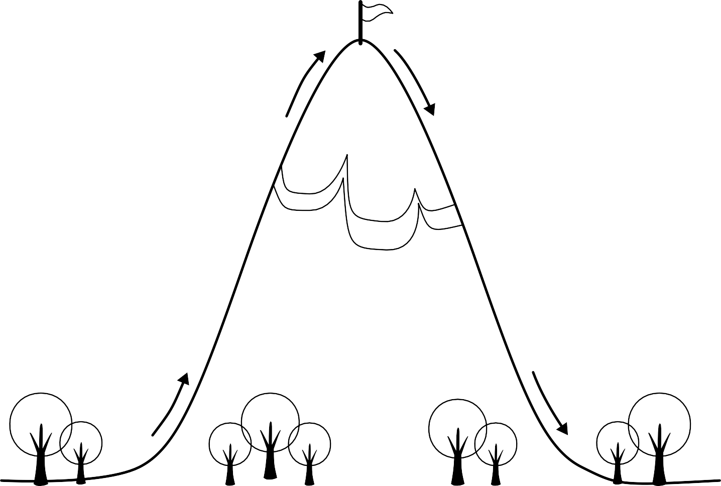

2. Rising Action

The things that happen to push the story forward as we head toward the climax.

4. Falling Action

The events that happened during the climax are dealt with.

##### 1. Exposition

We learn background information about the story’s characters, setting, and basic plot.

##### 5. Conclusion

The story comes to an end.

## Story Timeline

Fill in the plot timeline by deciding on the most important plot points of *Roll of Thunder, Hear My Cry* and recording them in the order they happen.

Beginning

1

2

3

4

5

6

7

8

End

## What is Conflict?

Conflict refers to the problems and challenges that make stories interesting and move plots along. Conflict is an important part of any story. Below are some of the different conflict types you may encounter as you read.

Man Versus Man

Two or more characters struggle against each other.

Man Versus Nature

A character struggles against a force of nature such as the weather or an animal.

Man Versus Society

A character struggles against a part of society such as a company, religion, school, etc.

Man Versus Self

A character struggles to overcome his or her own weaknesses.

Look for some examples of conflict in *Roll of Thunder, Hear My Cry*

and add them to the chart below.

|  |  |
| --- | --- |
| Example of Conflict | Type of Conflict |
|  |  |
|  |  |
|  |  |
|  |  |
|  |  |
|  |  |

Story Setting

The setting is the time and/or place in which a story happens.

1. Describe the setting of *Roll of Thunder, Hear My Cry*. When and where does it take place?
2. Draw a picture of a setting described in the story.
3. Explain what you have drawn above.

What is a Theme?

The theme a central topic or idea of a story. A story can have one or more themes. Some examples of themes are acceptance, cooperation, bravery and determination.

What do you think one theme of *Roll of Thunder, Hear My Cry* is?

One theme of *Roll of Thunder, Hear My Cry* is...

Find three examples from the book that supports this as one of the themes.

1.

2.

3.

Problem Solving

An important part of any story is the problem which the main character faces.

Write down the main problem faced in *Roll of Thunder, Hear My Cry* below, then brainstorm some possible solutions to the problem.

Solution Idea 1 Solution Idea 2



The Main Problem of the Story

Solution Idea 3 Solution Idea 4

Cause and Effect

An action or development in a story is the ‘cause’. The result of the action or development is the ‘effect’. Find some examples of cause and effect in *Roll of Thunder, Hear My Cry* and record them below.

Cause

Effect

Cause

Effect

Cause

Effect

## Character Types

In fictional stories, there are many different types of characters that play different roles.

Read about different character types below, and decide which character from *Roll of Thunder, Hear My Cry* fits each character type. (Some characters may fit more than one character type).

Major Characters

Major characters play a big part in the story. They influence the plot and take part in solving the main problem of the story.

**Example(s) from the book:**

Minor Characters

Minor characters pop up to help (or hurt) the story’s major characters.

**Example(s) from the book:**

The Protagonist

The protagonist is the main character of the story. Stories are often told from their point of view.

**Example(s) from the book:**

The Antagonist

The antagonist is the character (or characters) who causes problems

for the protagonist.

**Example(s) from the book:**

Dynamic Characters

Dynamic characters change through the story, usually because they overcome a challenge which makes them grow as a person.

**Example(s) from the book:**

Static Characters

Static characters do not change. Their personalities and attitudes are the same at the end of the story as they were at the beginning.

**Example(s) from the book:**

Round Characters

Round characters have complicated personalities and more than one character trait.

**Example(s) from the book:**

Flat Characters

Flat characters don’t have complicated personalities. Readers know them by only one character trait.

**Example(s) from the book:**



## Character Map

Write a different character name in each bubble below. Then, draw different styles of lines in different colors (as shown in the Relationship Key) to show the relationships

between each character.

Friends

Family Enemies

Relationship Key

Classmates/Co-workers

Teacher/Boss

Other

## Facts and Opinions



A fact is something that is proven to be true.

An example of a fact is, “The month after July is August”.

An opinion is a feeling or belief about something.

An example of an opinion is, “July is the best month of the year!”

In the spaces below, record four facts and four opinions about *Roll of Thunder, Hear My Cry*.

1.

F

A 2.

C

3.

T

S 4.

O 1.

### P

I 2.

### 

I 3.

### 

N 4.

### S

Persuasive Writing

To be *persuasive* is to be good at convincing people to think a certain way.

Write a persuasive passage in which you try to convince your readers that they should either read or not read *Roll of Thunder, Hear My Cry*. Make sure to include reasons for why you think the story is good or bad using examples from the text. For example, if you tell your readers that the story is funny, tell them about something funny that happens in the book.

With this passage, what do you hope to persuade your readers to do?

Read this book!

Don’t read this book!



## Quotation Quest

Skim the novel and write down three favorite quotations, or quotations you think are important to the story.



Quotation:

From page #

Why I chose this quotation:



Quotation:

From page #

Why I chose this quotation:



Quotation:

From page #

Why I chose this quotation:

## Character Comparison

Choose two characters from *Roll of Thunder, Hear My Cry* and compare them to each other.

What are their similarities and what are their differences?



Character 1



Character 2

The similarities these characters share



The differences between these characters

Character 1 Character 2

Story Comparison

Compare *Roll of Thunder, Hear My Cry* to another story you have read.

What are their similarities and what are their differences?

*Roll of Thunder, Hear My Cry*

###### The similarities these stories share



The differences between these stories

My Life - Making Connections

In the spaces below, make comparisons between your life and the life of a character of your choosing from *Roll of Thunder, Hear My Cry*.

Character Name:

Similarities

Differences

Name:

# Reading Log

Record information about the books you read on this chart.



|  |  |  |  |  |  |  |  |
| --- | --- | --- | --- | --- | --- | --- | --- |
|  |  |  |  |  |  |  |  |
|  |  |  |  |  |  |  |  |
|  |  |  |  |  |  |  |  |
|  |  |  |  |  |  |  |  |

**Common Core State Standards**

This novel study is aligned to the Common Core State Standards (U.S.)

Grade 5

RL5.1 Quote accurately from a text when explaining what the text says explicitly and when drawing inferences from the text.

RL5.2 Determine a theme of a story, drama, or poem from details in the text, including how characters in a story or drama respond to challenges or how the speaker in a poem reflects upon a topic; summarize the text. RL5.3 Compare and contrast two or more characters, settings, or events in a story or drama, drawing on spe- cific details in the text (e.g., how characters interact).

RL5.4 Determine the meaning of words and phrases as they are used in a text, including figurative language such as metaphors and similes.

L5.4 Determine or clarify the meaning of unknown and multiple-meaning words and phrases based on grade 5 reading and content, choosing flexibly from a range of strategies.

L5.5 Demonstrate understanding of figurative language, word relationships, and nuances in word meanings.

Grade 6

RL.6.1 Cite textual evidence to support analysis of what the text says explicitly as well as inferences drawn from the text.

RL.6.2 Determine a theme or central idea of a text and how it is conveyed through particular details; provide a summary of the text distinct from personal opinions or judgments.

RL.6.3 Describe how a particular story’s or drama’s plot unfolds in a series of episodes as well as how the characters respond or change as the plot moves toward a resolution.

RL.6.4 Determine the meaning of words and phrases as they are used in a text, including figurative and connotative meanings; analyze the impact of a specific word choice on meaning and tone

RL.6.5 Analyze how a particular sentence, chapter, scene, or stanza fits into the overall structure of a text and contributes to the development of the theme, setting, or plot.

RL.6.6 Explain how an author develops the point of view of the narrator or speaker in a text.

Grade 7

RL.7.1 Cite several pieces of textual evidence to support analysis of what the text says explicitly as well as inferences drawn from the text.

RL.7.2 Determine a theme or central idea of a text and analyze its development over the course of the text; provide an objective summary of the text.

RL.7.3 Analyze how particular elements of a story or drama interact (how setting shapes characters or plot).

RL.7.4 Determine the meaning of words and phrases as they are used in a text, including figurative

and connotative meanings; analyze the impact of rhymes and other repetitions of sounds (e.g., alliteration) on a specific verse or stanza of a poem or section of a story or drama.



#### Novel Study

Roll of ThundeR, heaR My CRy

by Mildred D. Taylor

###### Thank you for your purchase!

This product is licensed for use solely by the individual who purchased it.

**Please do not share/redistribute this file:**

**Uploading files to school and personal servers usually means that**

**the files will be accessible to anyone on the internet. Please do not upload this file to any webspace unless you know how to properly protect it from being accessed by others.**

The content of this file is not to be reproduced, edited, or used elsewhere without the permission of its author. © The Book Umbrella